## 

Bumble Safe Dates in 48

Social Media Campaign Proposal for Bumble

Candice Nguyen

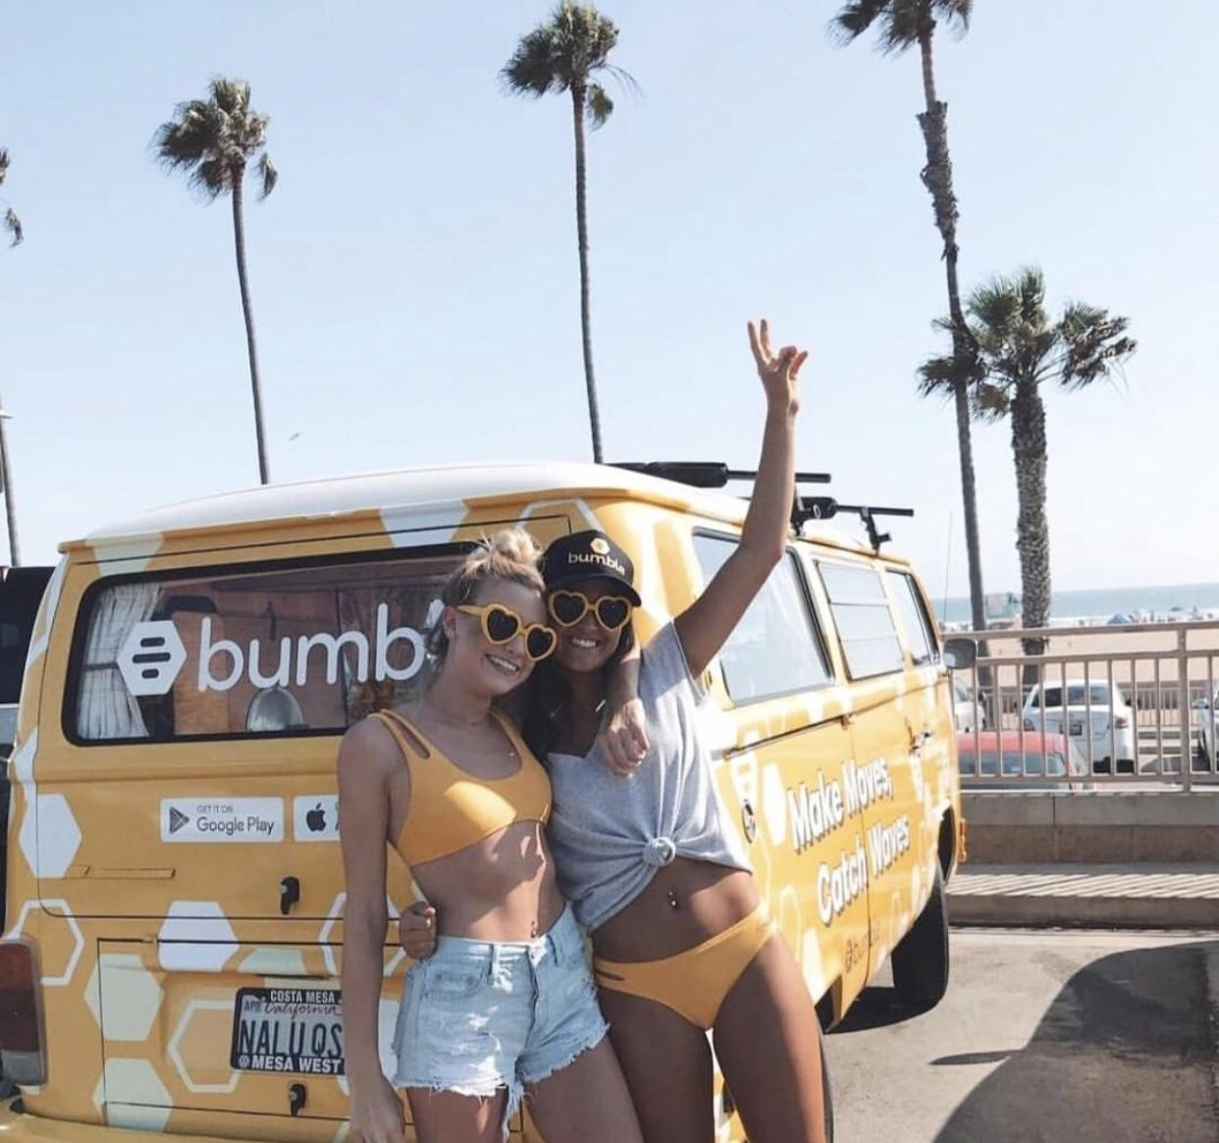

# 

# Overview

This proposal outlines the content strategy and tactics for the Bumble Safe Dates in 48 Campaign where we will showcase two Bumble Honeys, Candice Nguyen and Jess Phillips, “buzzing” from state to state in the official Bumble Van tooting Bumble’s horn and promoting safe dating during the pandemic. TikTok, Instagram, and YouTube will be the main platforms to promote this fun and original visual series.

This campaign was created in response to the COVID-19 global pandemic to enhance the new features Bumble has offered on the app to address the importance of social distancing while maintaining connections in a healthy manner. With coronavirus spreading across the U.S., the theme of the campaign emphasizes that social distancing does not equal loneliness. New features that are included in the app, such as settings for social distancing dates, emphasize that despite social distancing and mask-wearing, dating can still be a safe and fun activity.

The TikTok campaign will continue to give Bumble a strong presence on TikTok over Tinder and Hinge who have recently joined. Tinder and Hinge developed their own group of collaborators and partners to promote their own apps. As Bumble Safe Dates In 48's main platform would be TikTok, this gives more room for Tinder and Hinge to join other trends and create partnerships before the series has started. However, competition on the TikTok platform will not likely arise due to the low amount of content and engagement they are receiving within the first few weeks of building their newly made platform.

Overall, the campaign informs the Bumble community of the new advancements made in the app and how it can be used to benefit social connections during the pandemic. It will include a series of posts of socially distant date ideas and how it can be used in real life with light humor and entertaining date ideas that can be used in real life.

# Campaign Goals and Performance Metrics

|  |  |
| --- | --- |
| **Goal #1** | **Performance Metrics** |
| Increase app downloads by 5% | Sales figures pre/post-campaign |
| Increase followers | Follower counts pre/post-campaign |
| Increase social media engagement | Track likes, comments, views, shares |
| Generate 1000 entries to the photo contest | Measure the number of photos submitted with hashtags with #DistanceDate |
| Increase customer to brand engagement 20% | Responses to hashtags, comments on posts |
| Increase Bumble's CSR brand reputation | Brand mentions, track hashtags, sentiment analysis on comments |

# Target Audience

Bumble Safe Dates in 48 Campaign targets Bumble’s core demographic users ages 18-26 who may feel reluctant or discouraged from dating during the pandemic with the message that dating can still be safe. We are also targeting inactive users who may have given up on dating during the pandemic to become active again on the platform.

# Channel Strategy - Using TikTok and Instagram

The key platforms for this campaign are TikTok and Instagram due to the demographic of the platforms and Candice’s (TikTok and Instagram) and Jess’ (Instagram) expertise with these platforms.

1. **TikTok**

TikTok is truly an ideal platform for this campaign. TikTok users are predominantly 18-30-year-olds, which represents 26% of Bumble’s overall users and the most likely demographic to be currently dating or using online social networking.

Candice currently has 72k TikTok followers. She posts at least three times every day circling content around her role as a Bumble ambassador and additional lifestyle and humorous entertainment.

During the Bumble Safe Dates in 48 Campaign, she will post at least once every day during the entire road trip across the 48 states, highlighting previews to dates, the dates themselves, and the Bumble Vibe Checks, which is already a successful series Candice initiated last March and that regularly generates excellent engagement.

1. **Instagram**

On the Instagram accounts of Candice and Jess, the two Bumble Honeys traveling together will be posting regularly on their account to engage with their current audience.

Candice currently has 4,251 Instagram followers while Jess has 2,029 followers. They both post on a weekly to biweekly basis circulating their content around their roles as Bumble Ambassadors and additional lifestyle, travel content, and promotional posts for other brands.

During the Bumble Safe Dates in 48 Campaign, they will both post at least once every 2-3 days promoting previews to the dates, IGTV extensions of the TikTok dates, tips and tricks for match optimization, and reels of the TikToks posted. Candice and Jess, known for being Bumble Ambassadors, can use their audience to help promote the series by sharing to Bumble HQ - potentially being able to repost content on Bumble's main Instagram platform.

# Content Strategy

Using the hashtag #BumbleSafeDatesIn48, Candice and Jess will post a kick-off post and video to announce their upcoming travels in the official Bumble van. Once on the road, they will post videos from each of the states where they talk about how to use Bumble’s Bee-Line features promote safe dating, including how to find the right person using profile tags and Candice’s Bumble Vibe Checks, how to dine on the Bumble Bench and they will respond to followers’ comments and suggestions. They will document their zany adventures as they crash-safe dates and stage stunts like a Bumble Bachelorette contest complete an all-expense-paid safe date with Candice or Jess.

Here are some examples of the kind of content they will be posting:

[Dates in States](https://vm.tiktok.com/ZMJS1ERyR/)

[Bumble Vibe Check](https://vm.tiktok.com/ZMJBvwNLd/)

[Bumble Bachelorette](https://www.tiktok.com/@tropicalcandice/video/6832712169994358022?source=h5_m)

**Possible Campaign Expansion**

As momentum builds and as the Bumble Honeys draw closer to visiting each of the 48 states, the campaign can continue with a challenge to followers to get Candice and Jess sent to Alaska and/or Hawaii. Bumble can use the traction from the series to create their own sponsored challenge on TikTok which can encourage users to create their own version of a distance date using Bumble's features. With current or new users using Bumble, the campaign can challenge Bumble Partners and TikTok users to join with the Bumble Honies in their journey. The engagement rate along with the series could emphasize

# YouTube Launch

The content generated for the Bumble Safe Dates in 48 Campaign could be used to help launch the first YouTube account for Bumble. YouTube videos require more extensive details on each date aside from the timed templates TikTok provides. Since the campaign is called, "Bumble Safe Dates in 48," it can be implied that the campaign will run and unfold over the course of three weeks while traveling in the Bumble Van to multiple states using Bumble's new features for dates. The audience can engage with different posts by guessing the next location, giving their input on date suggestions, and tips on how to optimize matches on the app. The campaign will include a series of posts on Instagram, YouTube, and TikTok during the Summer between the weeks of July 6 - August 21.

Our content will focus on Bumble's platforms to post a series while following along with content on personal platforms and Bumble's Instagram. With this being said, the TikTok would be a preview for the launching of Bumble's YouTube account featuring the social distant dates more in-depth. The TikTok will be a preview to launch the YouTube account using Jess' expertise with video editing. The content will focus on the more extensive versions of the date including behind the scene previews, how to find the men, and the dates themselves. The launch of the YouTube platform will take place after the end of the road trip to create a deposit of content to post.

# Content Calendar

Excel Sheet with provided content calendar.

**Timeline**Plan over about 1-2 months, but it’s not necessarily consecutive.

**Day 1:** Intro of Campaign, First Date Compilation - Response to Coronavirus Pandemic

**Day 2:** Behind the Scenes with the Bumble Honeys (Engaging with the audience of the authenticity of the campaign - candid)

**Day 3:** Collaboration Date with Bumble Partner to drive a larger audience to Bumble Social Platforms and raise brand awareness with #BumbleSafeDatesIn48

**Day 4:** Travelling and showcasing the features of the Bumble Van while highlighting Bumble's Blog for ideas on potential virtual dates

**Day 5:** Third Date Post to engage with the audience and ask their opinions on what they would like to see next with #BumbleSafeDatesIn48

**Day 6:** Informative Post about how to optimize matches on the app. Link to blog posts to learn how to develop a larger range of connections and network

**Day 7:** Wellness posts about how to create dating mantras and what can be done in the future to improve dating habits.