Candice Nguyen
Professor May
COM 542
16 February 2022

Dragons Abroad: 3 Must-Do ICA’s

Let’s face it, when talking about studying abroad, it isn’t just any educational experience, it is a life-altering moment. Intensive courses abroad (ICA’s) offer the opportunity to have an international academic experience in a shorter period from a week to up to 10 days. As new programs are offered every year, ICA’s are conjoined with an on-campus course for a full hands-on experience. With Drexel University’s plan to return to in-person learning, what better way to get back into the educational groove than by packing a bag and studying abroad!

- Spring Break in the Netherlands: Global Project & Team Leadership

This freshman friendly opportunity focuses on team building, roles, and dynamics using a global and cross-cultural perspective. BUSN T380, a combined on-campus and abroad course, can be used as an elective for any business major while gaining international experience and development for resume building. By participating in this program, students will be able to travel to the Netherlands to learn fundamentals in project management while creating fun memories too!

- Spring Intensive in Little Haiti: Community Development & Resilience

For those interested in development, social enterprise, and environmental justice, HNRS T380 is an honors college course for students to learn civic engagement and impacts on communities they aim to serve. Experiential learning in Little Haiti, Miami, gives students the opportunity to learn the importance of a community-driven approach as a model for sustainable development. Recognizing influence of gentrification and underserved/under resourced communities can show participants the holistic approach to history, culture, and language.
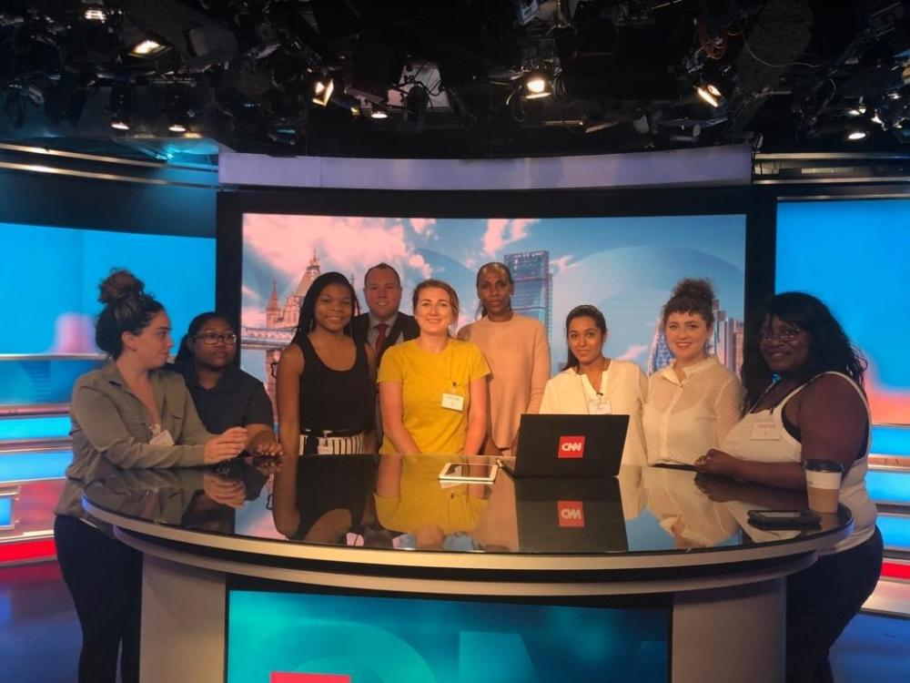
- Drexel Grad in London: Global Television Industry

If you’re a graduate student looking to get the most out of your educational experience, this ICA is perfect for you! TVMN T680 is a graduate course for both undergraduate and graduate students to bridge the gap between US and UK powerhouse television industries. The course consists of seminars with industry leaders from the UK and site visits hosted by professionals from BBC, CNN, NBC, and more. This program can serve significant social, political, economic, and cultural functions to just about everyone on the face of the earth!
Figure 1: London Group Photo at CNN. Credited to Drexel Study Abroad

Learn more about Drexel ICA.

Does this conversation need to drag-on and on any further?

I’ll leave it up to you! Want to study abroad soon? Which Drexel ICA looks the most fun? Want to learn more about other study abroad programs? Leave me a comment and let me know!

