Candice Customs Media Kit Final
Candice Nguyen
COM 542 | PR Writing
Cn453@drexel.edu
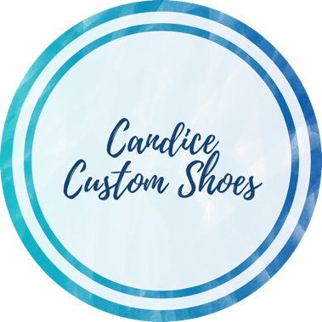
Candice Customs

3633 Spring Garden Street Philadelphia, Pennsylvania, 19104
Media Contact: Candice Nguyen
Founder and Public Relations Specialist
(856)562-0370
candice@candicecustoms.com

Backgrounder
Who are we?
Founded in 2018, Candice Customs creates one-of-a-kind, hand-painted custom shoes. With every order, Candice Customs aims to deliver the most creative shoes featuring professional designs by request. The founder, Candice Nguyen, uses her background in fine arts and marketing to give her customers a unique and memorable personal experience with their shoes.

The Candice Customs team is led by fellow employees:
- Founder and Public Relations Specialist Candice Nguyen
- Operations Manager Matthew Walker
- Social Media Manager Austin Nguyen
- Website Coordinator Ellen Park

What do we do?
Candice Customs strives to fulfill our clients’ dreams, desires, and expectations with custom painted shoes and sneakers. Based in Philadelphia, we offer value with each order by handling each pair with care and detail. Candice Customs offers promotions to customers through social media campaigns highlighting giveaways, discounts, and influencer partnerships in celebrations of events and special occasions. By satisfying the desires of custom, one-of-a-kind shoes, Candice Customs will continue to grow and impact the lives of customers for years to come.

Pricing
Pricing of each pair of shoes is dependent on shoes, designs, and labor. Factoring materials and designs, our shoes can typically range from $70 to $200 for kids, men’s, and women’s shoes. With our line of ready-made shoes, shoes can start from $140 to $200.

To order a pair of Candice Customs, check out our website at candicecustoms.com. Please contact customerservice@candicecustoms.com to inquire about personalized shoes and design options.

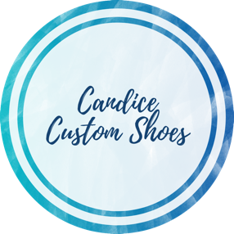
Press Contact:
Candice Nguyen
(856) 562-0370
candice@candicecustoms.com
www.candicecustoms.com

FOR IMMEDIATE RELEASE

Candice Customs Introduces New Hibiscus Shoes
Philadelphia, PA, March 13, 2022 - Candice Customs’ artist announced today the design and launch of Hibiscus shoes, a high-quality and hand-painted slip-on shoe. The new Hibiscus shoe product will be sold on the website on the line of ready-made designs, which feature hand-painted and made-to-order shoes, such as the iconic Sunflower-pattern shoes.

The next launch of Hibiscus shoes will be the beginning of many more designs coming in the next few months. According to Candice Nguyen, founder of Candice Customs, these new Hibiscus shoes allowed her to continue sharing her love of art to the Candice Customs family.

“The shoes are just-in-time for Spring and Summer with their vibrant pink, purple, and green colors that offer the same level of comfort and style as all of Candice Custom’s shoes,” said Nguyen.

MORE
The company will be releasing the new design for limited time only as a part of the Spring collection. According to Matthew Walker, Operations Manager of Candice Customs, the new shoes qualify for free standard shipping to anywhere in the U.S. and will be available through a newly designed website.

“Our newly designed website will include the sale of our Hibiscus shoes,” he said. “I am confident that all our customers will love this design as they complement those warm weather fits!”

More information on the ready-made shoes is expected to be released in the following weeks by the founder and other representatives from Candice Customs.

###

About Candice Customs:
Founded in 2018, Candice Customs aims to create one-of-a-kind custom pair of hand painted shoes to meet the desires and expectations of all our customers. With a variety of shoes, sneakers, and designs, each pair of custom shoes is catered to your unique and personal experiences. Based in Philadelphia, Candice Customs handle each pair with care and detail. For more information, visit www.candicecustoms.com.

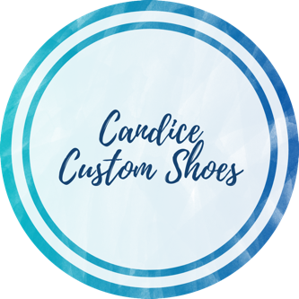
Candice Nguyen
3633 Spring Garden Street
Philadelphia, PA 19104
(856) 562-0370 | candice@candicecustoms.com

Candice Customs Product Fact Sheet

General Information
Founded in 2018, Candice Customs features professionally designed and hand-crafted custom shoes and sneakers. Within less than two months, the company reached just under $6,000 in sales, gained an Instagram following of over 6,000 followers, and partnered with famous celebrities for giveaways. Promotions for events or special occasions can be found primarily on Instagram including giveaways, discounts, and influencer partnerships.

Products
Candice Customs provides a variety of custom, hand-painted one-of-a-kind and ready-made shoes to wear. As it will give a customer a unique way to express their personality from the tip of their toes, the company aims to give a memorable experience to each shopper. Shoes can be made ready and available for each customer by demand. Each type of custom shoes is created with extreme care and detail shipped within a 3–4-week period.
Product Features
- Water and scratch resistant
- Designed to fit your foot and fit perfectly
- Increased comfort and modified designs
- Practical and unique for a brighter personality
- High value ensuring long-wear
- Durability from high quality materials
Pricing
Candice Customs products options are shoe size, design, and materials. Each pair of shoes provide customers with high-quality durability made to ensure long wear time. Options are listed below:

In women’s sizes:
- Checkerboard Nike AF1s: $200
- Honeycomb Nike AF1s: $200
- Personalized Nike AF1s: $220
- Sunflower Vans: $150
- Hibiscus Vans: $150
- Personalized Vans: $175

In kid’s sizes, prices can be reduced by $75 less, while men’s sizes are increased by $25.

###

